CREATE A CHATBOT USING PYTHON :

ARTIFICAL INTELLIGENCE

The Components of an AI ChatBot

Functional Components

The functional components are those that help you create your ChatBot and allow it to function. They include the AI assistant you will use in the chat interface and the software to write the generated chat messages.

There are some situations where available components will not be appropriate, and you will not be able to create an effective ChatBot.

UI Elements :

The UI elements are those that help you create the ChatBot user interface. There are many UI elements that you can use.

Some of the more critical UI elements are the appearance of the input field, the search field, and the error area. These elements will help you to create a ChatBot that is easy to use and that works efficiently. You need to choose the appropriate input type, and for that, you can add a visual element such as boxes.

You can also add a checkbox or button to the user interface or create an error area, a form field, or a welcome area. This flexibility is all possible with the help of the interface element. A well-designed user interface is easy to use and works efficiently to identify the user and the information that the user needs.

There are also other user interface elements that you can use to create an AI ChatBot. These include icons or clickable elements that allow users to interact with your ChatBot. The clickable elements can also be linked with clickable fields and pop-ups. These pop-up boxes will appear whenever a user wants to interact with your ChatBot. The ChatBot that you are designing can support interactions by expanding and collapsing boxes.

Creating an AI ChatBot

An AI ChatBot can speed up the development of your user-facing application. A ChatBot is easy to install and cheap to operate.

It is good to remember that there are many types of ChatBots, but there are only two main classes of ChatBots: personal and business ChatBots. Personal ChatBots are those that are designed to interact with users in a unique context. Business ChatBots are designed to interact with users in a business context.

With the help of a ChatBot, you can monitor and control the user’s interaction with your application. If the user opens the ChatBot and tries to enter something inappropriate, the AI ChatBot can detect this and punish the user. A good ChatBot can know what the user’s intention is.

It is a good idea to create a ChatBot that can learn. AI ChatBots are three components: the ChatBot, the user interface, and the backend technology.

Building an AI ChatBot

You can use the most popular ChatBot software to create an AI ChatBot. The most popular tools you can use are Microsoft’s Skype, Facebook Messenger, Google Chat, etc.

You can create an NLP ChatBot if you have a special relationship with a ChatBot to understand the user’s natural language. The second type of ChatBot is

You can also create custom ChatBots using other tools such as WordPress. The code that you have to write is the same, but you have to modify the information or the interface of the custom ChatBot.

The goal of the ChatBot software is to manage the conversation the Bot and the Customer are having. Conversations are often managed through decision trees, but AI is now offering more choices. AI can now interpret questions from customers and dynamically change the response. The challenge is that the user interface must be appropriate for the customer. For instance, the customer could be using a Web browser to connect with the chatbot. That is a traditional Chatbot experience. However, the Chatbot technology can be easily adapted to other user interface experiences such as mobile apps and text messaging.

AI Chatbot Design Guidelines

Now that the basic framework for your ChatBot is in place let’s look at the general design guidelines you need to follow. There are many different types of AI ChatBots that you could come up with. For our discussion, we’re going to look at the ChatBot that runs the site x.ai. The ChatBot uses a set of tones that you will customize for your needs. You can change these tones at any time as well. The techniques are neutral, and they have been named according to the people they are trying to reach.

The first design guideline for an AI ChatBot is that it should be relatively easy to navigate and look through all available features. You can change the color scheme as well, and you can change the functionality of the tones as well.

### The Three-Level Pyramid

The purpose of the ChatBot is to allow users to place and receive phone calls from businesses quickly. The main objective is to give users the experience of talking to an actual person over the phone. This experience can be achieved by using an interface that makes it easier to create a phone call, and this interface is called the Three-Level Pyramid.

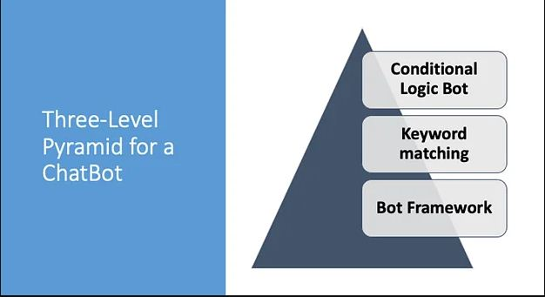

As the application developer, you are supposed to provide users with this interface and a call-waiting feature. You have to allow users to choose from several preset voices or create a personal representative that the user can use whenever he wants. The third design element for an AI ChatBot is the call-waiting feature that allows the user to create a phone call before he places the call.

In the Three-Level Pyramid, the call-waiting feature is an intermediary step between the user and the actual phone call. You can have the user add some information to the waiting queue as well, and you can notify the user after the exchange has been completed.

In this example, the user can place a call to a secretary at one of the companies that provide cleaning services. The user can click on “Secretary,” which then calls a secretary of the company. The user also can place a call to the actual person, and he can choose to do so after some time. This feature allows the user to have some time to think about the person before he makes the call.

The second design guideline for an AI ChatBot is that the interface must be accessible. In this design, we have a total of five different screens that are accessible by the user. You can add a unique feature to each of these screens as well.

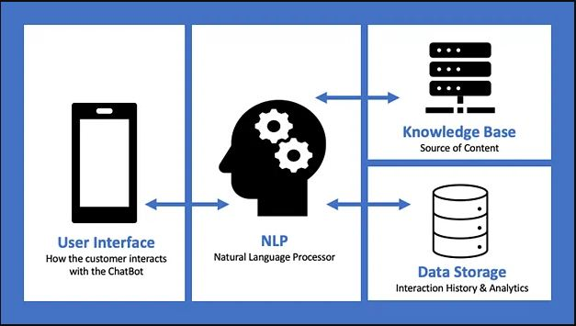

You have to create a level hierarchy based on the complexity of the system. The better the ChatBot design, the higher the level of complexity. In the above image, you can see an example of the complexity levels of the UI and UX design of a ChatBot that can handle basic conversations.

The third design guideline for an AI ChatBot is to use an interface for each channel in the Three-Level Pyramid. This guideline means that you need to create a user interface for each channel users interact with. You have to design the interface based on the interface you have prepared for the first user interaction with the ChatBot.

The same interface will work for each of the subsequent user interactions as well. When you create a ChatBot, it is essential to remember the fundamental principles of user interface design. User interface design refers to the creation of the interface that the user interacts with. Keep in mind that most people interact with your ChatBot with the help of a keyboard.

A user interface designed for keyboards will have specific requirements. In most cases, three elements are relevant to the keyboard interface: the “home” button, the “menu” button, and the “delete” button.

You will have to design these elements, and you can create them according to the type of input that the user will use. You will have to design one, two, or all three elements depending on the size of the screen that the user uses.

### Next Steps

The intelligence that powers ChatBots is significantly increasing. We are moving quickly towards ChatBots responding with a perfect human voice. You will not know that you are talking with a computer. Expect this level of advancement before the end of 2022. Yes, the advances are coming that quickly.

Now is the time to get started with ChatBots. Many tools make it easy. The guidelines in this article will help you keep the project on track.